Form Due: September 30, 2019
Please email completed form to Anna McGovern: amcgovern@alaskachildrenstrust.org

Thank you for submitting a workshop proposal for the Alaska Afterschool Conference. All proposals will be reviewed by our conference selection committee. Below are a few areas of interest for workshop proposals:

-Social/Emotional Learning (SEL) | -Behavior management
-Trauma Informed Practice | -Program management
-Culturally-Responsive programming | -Family engagement
-STEM or STEAM | -Inclusive programming for youth with disabilities
-College & Career Readiness | -Language Arts
-Secondary programs/teen programming | -Health & Wellness (physical fitness, nutrition)
Substance Use Prevention

PRESENTER INFORMATION
Presenter: Enter First and Last Name Here
Organization/Affiliation:Enter Organization Name Here.
Address: Enter Address Here
City: Enter City Here. | State: Enter State Here | Zip code: Enter Zipcode Here
Phone(s): Enter Phone Number Here
Email(s):Enter Email Here

Brief Bio(s):  (Bios may be read aloud by room host at the start of the workshop)  Maximum 565 characters | Enter  Info  Here

SESSION DESCRIPTION
Workshop Title: Enter Workshop Title Here
Workshop Description  Maximum 565 characters | Enter  Info  Here

Intended Audience:
Instructors of Elementary ☐ | Coordinators/Directors/Managers ☐
Instructors of Middle School ☐ | Instructors of High School ☐
All ☐ | Other ☐

INSTRUCTIONAL PLAN
Learning  Methods:  (What type of teaching methods will be used in this session, e.g. lecture, interactive, hands-on?) | Enter  Info  Here
Training Outcomes:  (Training outcomes specify what the participant will gain, do, learn more about, and/or be able to demonstrate at the end of the session) | Enter  Info  Here
Reflection  And  Assessment:  (How will you help participants to reflect throughout session? Will you have them verbalize, write, take survey, or have them reflect in another way?) | Enter  Info  Here

Preferred Session Time : Choose a Time
50 minutes ☐ 75 minutes☐

AV Needs (please check all items needed):
LCD Projector ☐ Computer☐ Speakers☐
Chart Paper & Markers☐ Other ☐
Additional Comments: | Enter  Info  Here

Please plan for up to 40 participants. All presenters will be responsible for supplying their own copies of materials.

When submitting your workshop proposal form, save your file as the title of your workshop. If you have any questions, need help filling out the presenter form, please contact Anna:
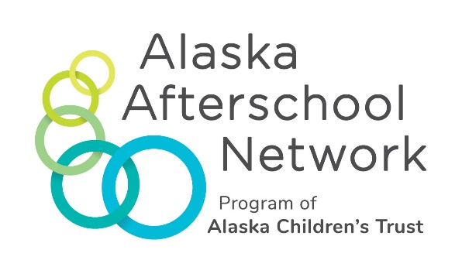

Anna McGovern
Afterschool Program Specialist
3201 C Street, Suite 110
Anchorage, Alaska 99503
Office (907) 248-7372
amcgovern@alaskachildrenstrust.org

